AIM:- To write a Program to stimulate cp command

Description:-

The Command cp is used to copy the contents of one file to another file
Syntax In unix : - cp [source filename] [destination file name]
cp command will overwrite files without asking. If the destination file name already exists, its data will be destroyed.

Algorithm:-

1)Initialize Two File pointers to Identify source and destination file.
2)Initialize Two char arrays which acts as buffer space for Storing the information of the source file to copy . Read the file names using gets() function.
3)Assaign the File pointers using fopen() function.
Note :- Open the Source file in read mode and Destination File in Write Mode.
4)if the fopen(source) returns “NULL” that means the source file doesnot exist so,terminate the entire program.
5)if the sorce file exists , Until we reach the end of the file , we read each character in source file and place that chaacter in destination file.
6)Close Both Files.

Libraries Used:-

Header Files:-stdio.h , stdlib.h
Functions Used:

1)fopen():-
Syntax:-Declaration: FILE *fopen (const char *filename, const char *mode)

fopen() function is used to open a file to perform operations such as reading, writing etc. In a C program, we declare a file pointer and use fopen() as below. fopen() function creates a new file if the mentioned file name does not exist.
FILE *fp;
fp=fopen (“filename”, ”‘mode”);

Where,
fp – file pointer to the data type “FILE”.
Filename – the actual file name with full path of the file.
mode – refers to the operation that will be performed on the file. Example: r, w, a, r+, w+ and a+.
fclose():-
Declaration: int fclose(FILE *fp);
fclose() function closes the file that is being pointed by file pointer fp. In a C program, we close a file as below.
fclose (fp);
gets() :-

Declaration: char *gets (char *string)

gets functions is used to read the string (sequence of characters) from keyboard input.
In a C program, we can read the string from standard input/keyboard as below.

gets (string);

fputc() :-

Declaration: int fputc(int char, FILE *fp)

fputc functions is used to write a character into a file. In a C program, we use fputc() function as below.
returns the character that is written in case of successful write operation else in case of error EOF is returned.

fputc(ch, fp);

where,
ch – character value
fp – file pointer

fgetc():-

Declaration: int fgetc(FILE *fp)

fgetc function is used to read a character from a file.
It reads single character at a time. In a C program, we use fgetc() function as below.

This function returns the number of characters read by the function.
fgetc (fp); where , fp – file pointer

Code :-

#include <stdio.h>
#include <stdlib.h>
int main()
{
char ch, source_file[20], target_file[20];
FILE *source, *target;

printf("Enter name of file to copy\n");
gets(source_file);

source = fopen(source_file, "r");

if (source == NULL)
{
printf("Press any key to exit...\n");
exit(EXIT_FAILURE);
}

printf("Enter name of target file\n");
gets(target_file);

target = fopen(target_file, "w");

while ((ch = fgetc(source)) != EOF)
fputc(ch, target);

printf("File copied successfully.\n");

fclose(source);
fclose(target);

return 0;
}

Output:-

Case 1:-

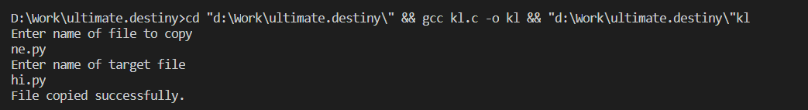

Case 2:-

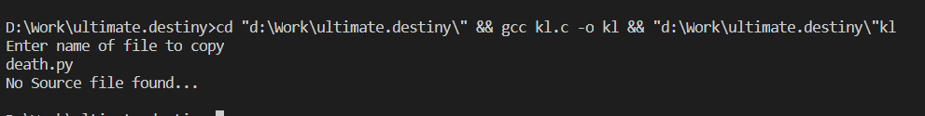
Observations:-

cp -R SRCFOLDER DESTFOLDER/

The following command can be used to copy contents in a directory recursively. This works because in
Unix OS everything is considered as a file.

Cp command can take multiple arguments .

This is mainly used when we want to copy files to a directory .

cp Src_file1 Src_file2 Src_file3 Dest_directory

Note :- mv command can be stimulated by the same program but before the fclose(source) command we need to enter

int status=remove(source)

cp is used to copy soruce file into destination file ,

where are mv is used to replace a file. (it can also be called as renaming a file).

AIM :- To Write a C program to Stimulate ls -l command

Description:-

To list files in a specific directory, pass the path to the directory to the ls command.

The default output of the ls command shows only the names of the files, which is not very informative. When the long listing format is used the ls -l command will display the following file information:

The file type
The file permissions
Number of hard links to the file
File owner
File group
File size
Date and Time
File name

The -l option causes ls to print files in long listing format.

Algorithm:-

Input :-n/a
Output :- Detailed list of files and directories present
Description:-The ls – l is used for long listing the information about files and directories present

Libraries used:-
Stdio.h :- This Header file in included for performing basic operations like printing and scanning.
Sys/stat.h:- This header file contains functions and structures required to know the status of a file
fileStat Structure:- this is a stat structure which composes of stmode ,s_isdir ,st.size.., variables
to know about the file information
dirent.h: this header file is included to get the dirent structure to point to a file.
Time.h:- ctime():- this method is used to get the time of modification on a file.
Grp.h:-this header files contains the properties required for a group ,Structure Group is being used here
Pwd.h:- this header file is included to know about the present working users on a file at that particular moment.

Code :-

#include<stdio.h>
#include<sys/stat.h>
#include<stdlib.h>
#include<dirent.h>
#include<time.h>
#include<grp.h>
#include<pwd.h>
int main(int argc, char **argv)
{
struct passwd *pw;
struct group *gp;
DIR *mydir;
char *c;
int i;
struct dirent *myfile;
struct stat fileStat;
mydir=opendir(".");
stat(".",&fileStat);
while((myfile=readdir(mydir))!=NULL)
{
stat(myfile->d_name,&fileStat);
printf( (S_ISDIR(fileStat.st_mode)) ? "d" : "-");
printf( (fileStat.st_mode & S_IRUSR) ? "r" : "-");
printf( (fileStat.st_mode & S_IWUSR) ? "w" : "-");
printf( (fileStat.st_mode & S_IXUSR) ? "x" : "-");
printf( (fileStat.st_mode & S_IRGRP) ? "r" : "-");
printf( (fileStat.st_mode & S_IWGRP) ? "w" : "-");
printf( (fileStat.st_mode & S_IXGRP) ? "x" : "-");
printf( (fileStat.st_mode & S_IROTH) ? "r" : "-");
printf( (fileStat.st_mode & S_IWOTH) ? "w" : "-");
printf( (fileStat.st_mode & S_IXOTH) ? "x" : "-");
printf(" ");
printf("%d ",fileStat.st_nlink);
pw=getpwuid(fileStat.st_uid);
printf("%s ",pw->pw_name);
gp=getgrgid(fileStat.st_gid);
printf("%s ",gp->gr_name);
printf("%4d ",fileStat.st_size);
c=ctime(&fileStat.st_mtime);
for(i=4;i<=15;i++)
printf("%c",c[i]);
printf(" ");
printf("%s\n",myfile->d_name);
}
closedir(mydir);
return 0;
}

Outputs:-

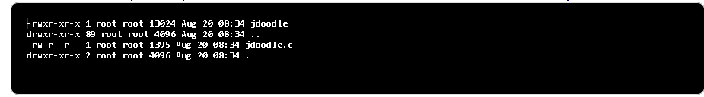

Observation:-

The permission character can take the following value:
r - Permission to read file
w - Permission to write to file
x- Permission to execute file
s- setgid bit
t- sticky bit

setgid bit has effect on both files and directories. In the first case, the file which has the setgid bit set, when executed, instead of running with the privileges of the group of the user who started it, runs with those of the group which owns the file: in other words, the group ID of the process will be the same of that of the file.

The sticky bit works in a different way: while it has no effect on files, when used on a directory, all the files in said directory will be modifiable only by their owners. A typical case in which it is used, involves the /tmp directory. Typically this directory is writable by all users on the system, so to make impossible for one user to delete the files of another one, the sticky bit is set:

WEEk-3

Aim : to demonstrate fork() system call using c programming

Description:-

Fork system call use for creates a new process, which is called child process, which runs concurrently with process (which process called system call fork) and this process is called parent process. After a new child process created, both processes will execute the next instruction following the fork() system call. A child process uses the same pc(program counter), same CPU registers, same open files which use in the parent process.

Libraries Used :-

sys/types.h:-
This header file is included to utilize fork() command.

Fork():-

i/p:- none
o/p:-
Negative Value: creation of a child process was unsuccessful.
Zero: Returned to the newly created child process.
Positive value: Returned to parent or caller. The value contains process ID of newly created child process.

Code:-

#include <stdio.h>
#include <sys/types.h>

#define MAX_COUNT 200

void ChildProcess(void);
void ParentProcess(void);

void main(void)
{
pid_t pid;

pid = fork();
if (pid == 0)
ChildProcess();
else
ParentProcess();
}

void ChildProcess(void)
{
int i;

for (i = 1; i <= MAX_COUNT; i++)
printf(" This line is from child, value = %d\n", i);
printf(" *** Child process is done ***\n");
}

void ParentProcess(void)
{
int i;

for (i = 1; i <= MAX_COUNT; i++)
printf("This line is from parent, value = %d\n", i);
printf("*** Parent is done ***\n");
}

Output:-

Case 1:- max_count=15

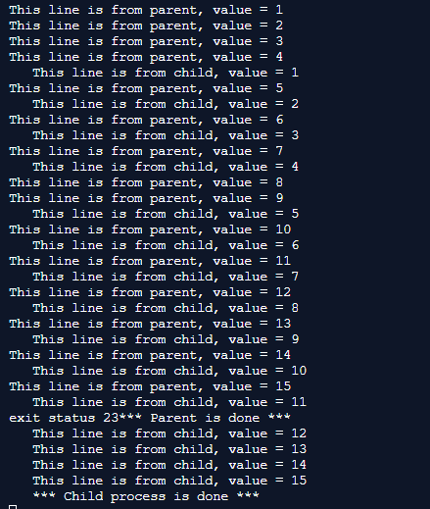

Case 2:- max_count=5
w
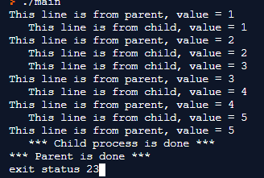

Case 3:- max_count=2
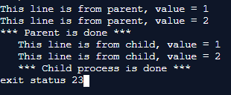

Observation:-

The fork command duplicates the process , it maintains a copy until the process is terminated. It does not terminate the previous process to start a new process.It creates a new process which is a copy of the calling process. That means that it copies the caller's memory (code, globals, heap and stack), registers, and open files. The calling process returns from fork() with the pid of the newly created process (which is called the "child" process. The calling process is called the "parent" process). The newly created process, as it is a duplicate of the parent, also returns from the fork() call (this is because it is a duplicate -- it has the same memory and registers, and thus the same stack pointer, frame pointer, and program counter, and thus has to return from the fork() call). It returns with a value of zero. This is how you know what process you're in when fork() returns.

In the output it is clearly observed that the parent process and child process can exist simulatneously.

fork() creates a new process by duplicating the calling process, The new process, referred to as child, is an exact duplicate of the calling process, referred to as parent, except for the following :
The child has its own unique process ID, and this PID does not match the ID of any existing process group.
The child does not inherit its parent’s memory locks and semaphore adjustments.
The child does not inherit any i/o operations from parent

AIM:-Program to Demonstrate EXEC() family commands.

Algorithm:-
The working Of exec is
Current process image is overwritten with a new process image.
- New process image is the one you passed as exec argument
- The currently running process is ended
- New process image has same process ID, same environment, and same file descriptor (because process is not replaced process image is replaced)
- The CPU stat and virtual memory is affected. Virtual memory mapping of the current process image is replaced by virtual memory of new process image.

Description:-

exec family commands:-
int execlp( const char *file, const char *arg, ... );

int execle( const char *path, const char *arg, ..., char *const envp[] );
int execvp( const char *file, char *const argv[] );
int execve( const char *file, char *const argv[], char *const envp[] );

exec is used when the user wants to launch a new file or program in the same process.The return type of these functions is Int. When the process image is successfully replaced nothing is returned to calling function because the process that called it is no longer running. But if there is any error -1 will be returned. If any error is occurred an errno is set.
In the syntax:
- path is used to specify the full path name of the file which is to be executes.
- arg is the argument passed. It is actually the name of the file which will be executed in the process. Most of the times the value of arg and path is same.
- const char* arg in functions execl(), execlp() and execle() is considered as arg0, arg1, arg2, …, argn. It is basically a list of pointers to null terminated strings. Here the first argument points to the filename which will be executed as described in point 2.
- envp is an array which contains pointers that point to the environment variables.
- file is used to specify the path name which will identify the path of new process image file.
- The functions of exec call that end with e are used to change the environment for the new process image. These functions pass list of environment setting by using the argument envp. This argument is an array of characters which points to null terminated String and defines environment variable.

Execlp:-
The execlp system call duplicates the actions of the shell in searching for an executable file if the specified file name does not contain a slash (/) character. The search path is the path specified in the environment by the PATH variable. If this variable isn’t specified, the default path ":/bin:/usr/bin" is used.
The execlp system call can be used when the number of arguments to the new program is known at compile time.

Execle:-
The execle() function replaces the current process image with a new process image specified by path. The new image is constructed from a regular, executable file called the new process image file. No return is made because the calling process image is replaced by the new process image.

Execvp and execve:-
The execvp() and execve ,function replaces the current process image with a new process image specified by path. The new image is constructed from a regular, executable file called the new process image file. No return is made because the calling process image is replaced by the new process image.

Code:-

execlp:-

#include <unistd.h>
#include <stdio.h>
#include <stdlib.h>
int main(void)
{
execlp("ls", "ls", "-l", NULL);
perror("Return from execlp() not expected");
exit(EXIT_FAILURE);
}

execle:-
#include <unistd.h> // execv()
#include <stdio.h> // perror()
#include <stdlib.h> // EXIT_SUCCESS, EXIT_FAILURE

void main() {
int ret;
char *env[] = { "HOME=/usr/home", "LOGNAME=home", (char *)0 };
ret = execle ("/bin/ls", "ls", "-l", (char *)0, env);

}

execvp:-

#include <unistd.h> // execvp()
#include <stdio.h> // perror()
#include <stdlib.h> // EXIT_SUCCESS, EXIT_FAILURE

int main(void) {
char *const cmd[] = {"ls", "-l", NULL};
execvp(cmd[0], cmd);
perror("Return from execvp() not expected");
exit(EXIT_FAILURE);
}

execv:-
#include <unistd.h> // execv()
#include <stdio.h> // perror()
#include <stdlib.h> // EXIT_SUCCESS, EXIT_FAILURE

int main() {
char *const argv[] = {"/bin/ls", "-l", NULL};
execv(argv[0], argv);
perror("Return from execv() not expected");
exit(EXIT_FAILURE);
}
execve:-

#include <unistd.h> // execv()
#include <stdio.h> // perror()
#include <stdlib.h> // EXIT_SUCCESS, EXIT_FAILURE

void main() {
int ret;
char *cmd[] = { "ls", "-l", (char *)0 };
char *env[] = { "HOME=/usr/home", "LOGNAME=home", (char *)0 };
ret = execve ("/bin/ls", cmd, env);
}

Output:-
for execlp execle execvp and execve:-

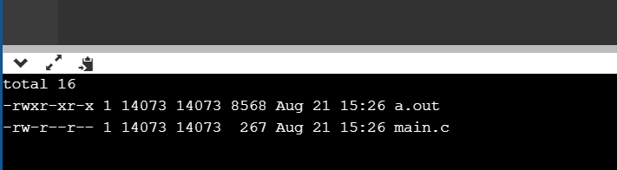

Note :- Executed in online c compiler.

Observation:-
The calls with v in the name take an array parameter to specify the argv[] array of the new program.
The calls with l in the name take the arguments of the new program as a variable-length argument list to the function itself.
The calls with e in the name take an extra argument to provide the environment of the new program; otherwise, the program inherits the current process's environment.
The calls with p in the name search the PATH environment variable to find the program if it doesn't have a directory in it (i.e. it doesn't contain a / character). Otherwise, the program name is always treated as a path to the executable.

The execXX family commands are all used to terminate a process inorder to start another one.
There is no special exec command but we rather use these execfamily commands .the
entire purpose of the exec command is to start a new process

WEEK-4

Aim:- To design an algorithm for round robin scheduling.

Description:-

To schedule processes fairly, a round-robin scheduler generally employs time-sharing, giving each job a time slot or quantum(its allowance of CPU time), and interrupting the job if it is not completed by then.

The job is resumed next time a time slot is assigned to that process.
If the process terminates or changes its state to waiting during its attributed time quantum, the scheduler selects the first process in the ready queue to execute.

In the absence of time-sharing, or if the quanta were large relative to the sizes of the jobs, a process that produced large jobs would be favoured over other processes.

Round-robin algorithm is a pre-emptive algorithm as the scheduler forces the process out of the CPU once the time quota expires.

Algorithm:-

Input :- no.of processes ,The Execution times(Burst times)and arrival times for the processes

Output:-turn around time ,waiting time of each process ,
average waiting time

1-Create an array rem_bt[] to keep track of remaining
burst time of processes. This array is initially a
copy of bt[] (burst times array)
2- Create another array wt[] to store waiting times
of processes. Initialize this array as 0.
3- Initialize time : t = 0
4- Keep traversing the all processes while all processes
are not done. Do following for i'th process if it is
not done yet.
a- If rem_bt[i] > quantum
(i) t = t + quantum
(ii) bt_rem[i] -= quantum;
c- Else // Last cycle for this process
(i) t = t + bt_rem[i];
(ii) wt[i] = t - bt[i]
(ii) bt_rem[i] = 0; // This process is over
Program:-
#include<stdio.h>
int main()
{

int count,j,n,time,remain,flag=0,time_quantum;
int wait_time=0,turnaround_time=0,at[10],bt[10],rt[10];
printf("Enter Total Process:\t ");
scanf("%d",&n);
remain=n;
for(count=0;count<n;count++)
{
printf("Enter Arrival Time and Burst Time for Process Process Number %d :",count+1);
scanf("%d",&at[count]);
scanf("%d",&bt[count]);
rt[count]=bt[count];
}
printf("Enter Time Quantum:\t");
scanf("%d",&time_quantum);
printf("\n\nProcess\t|Turnaround Time|Waiting Time\n\n");
for(time=0,count=0;remain!=0;)
{
if(rt[count]<=time_quantum && rt[count]>0)
{
time+=rt[count];
rt[count]=0;
flag=1;
}
else if(rt[count]>0)
{
rt[count]-=time_quantum;
time+=time_quantum;
}
if(rt[count]==0 && flag==1)
{
remain--;
printf("P[%d]\t|\t%d\t|\t%d\n",count+1,time-at[count],time-at[count]-bt[count]);
wait_time+=time-at[count]-bt[count];
turnaround_time+=time-at[count];
flag=0;
}
if(count==n-1)
count=0;
else if(at[count+1]<=time)
count++;
else
count=0;
}
printf("\nAverage Waiting Time= %f\n",wait_time*1.0/n);
return 0;
}

Outputs:-
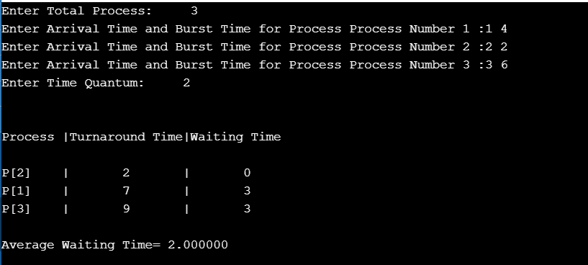

Observation:-

